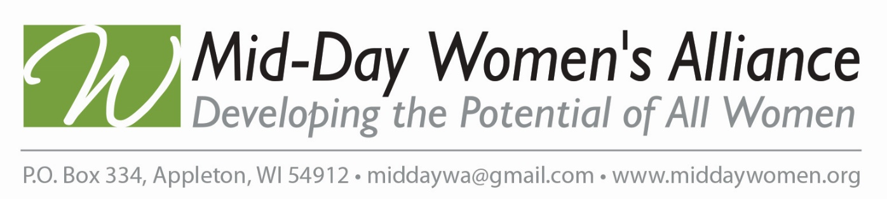

HISTORY OF MID-DAY WOMEN’S ALLIANCE LEGISLATIVE ACTIONS
1930s BPW/USA worked to prohibit legislation denying jobs to married women. BPW/USA lobbied successfully to legislatively end the legal practice of workplace preference for unmarried persons and, in the case of married persons, preference for males.
1940s World War II, BPW/USA developed a classification system for women with specialized skills critical to the effort and supported the formation of women’s branches of the Armed Forces. While wage discrimination has existed in the U.S. since women and minorities first entered the paid workforce, its prevalence was not felt until the massive influx of women sought work during World War II. Immediately following the war, the Women’s Pay Act of 1945 - the first ever legislation to require equal pay - was introduced in the U.S. Congress. It would take another 18 years before an equal pay bill would make it to the President’s desk to be signed into law.
1960s President Kennedy recognized BPW/USA’s leading role in securing passage of the Equal Pay Act by giving BPW/USA’s National President the first pen he used when signing the Act into law. Women earned 59 cents to the man’s $.
1970s BPW/USA intensified efforts to eliminate discrimination based on sex and marital status in credit, capital, and insurance practices.
1980s BPW/USA tackled “comparable worth” by calling for newspapers to stop the occupational segregation in classified ads (clustering of women in a few restricted occupations of low-paying, dead-end jobs). Numerous state and municipal governments revamped their pay scales.
The “Red Purse Campaign” of 1988 drew national attention to wage disparity. Using the “BPW” letters to represent Better Pay for Women, BPW/USA capitalized on the national media attention focused on the red purse.
1990s Workplace equity issues including sexual harassment, the glass ceiling, health care reform, dependent care, tort reform, increasing the minimum wage, lifetime economic security and pay equity continued to be BPW/USA’s targeted issues. Then-Secretary of Labor, Elizabeth
Dole, and First Lady Barbara Bush addressed BPW/USA’s members at the White House Briefing during the 1990 “Lobby Day” event.
1994 (BPW/USA) members lobbied their Members of Congress successfully convincing them to pass the groundbreaking Violence Against Women Act (VAWA), which included millions of dollars in state grants to combat violence against women. The programs created by VAWA have also been successful at providing victims with emergency shelter, hotlines, and supportive services.
2000s BPW/USA expanded its initiative to include education and awareness focusing on pay equity, dependent care, workplace flexibility, and social security reform -keeping social security a guaranteed part of retirement.
2005 BPW/USA successfully urged the Bureau of Labor Statistics to continue collecting data on women workers in the CES (Current Employment Statistics Survey) after they announced they would cease collecting it after July 2005. 2007 Census Bureau reported 77.8%
VAWA (Violence Against Women Act) was set to expire in September 2005 and BPW/USA made the VAWA reauthorization a top legislative priority.
2010 Throughout the years, three major issues shaped BPW/USA’s legislative agenda: elimination of sex discrimination in employment, the principle of equal pay, and the need for a comprehensive equal rights amendment.
2012 Mid-Day Women’s Alliance is now a 501(c)6 corporation, filed as a trade or business organization in the state of Wisconsin. Our by-laws govern how we conduct business, and we have our own board of directors, legislative platform modeled after BPW’s platform, tax-exempt status, insurance, etc. When the WWA was disbanded, the amount of funds that came back to Appleton from the WWA account was invested into a donor-directed fund, the MDWA fund, held at the Women’s Fund. This endowed fund allows us to direct the annual spending policy to a charitable organization of our choice.
Where will MDWA go in the future? We are glad you are going to be a part of it!

