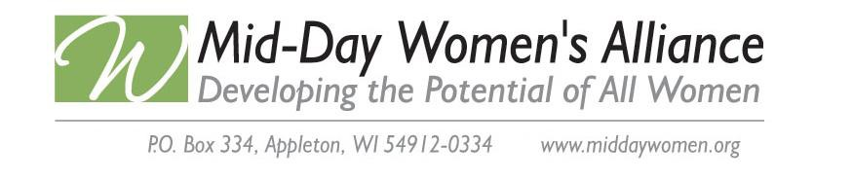

MDWA Legislative Platform

Mission Statement of MDWA
The mission of Mid-Day Women’s Alliance shall be to promote equity for all women* and to develop their potential through advocacy, mentoring, networking, skill building and education. Mission of Legislation Program
To advance equity for all women, the mission of MDWA’s Legislation program is to identify and take action on legislation consistent with our platform: pay equity, equal opportunities for women in the workplace and schools, women’s health issues, and ending all violence and acts of discrimination against women in accordance with the United Nations Convention for the Elimination of all Discrimination against Women (CEDAW) .

Preamble
Because fundamental law is embodied in our governmental constitution and all statutory rights are derived from the U.S. Constitution, support of the Alice Paul Equal Rights Amendment and the UN-CEDAW, shall stand first and foremost above all other items which may appear on the Legislative Platform until equal rights for all citizens are constitutionally guaranteed.

Purpose
Mid-Day Women's Alliance supports the right of women to develop to their fullest potential and encourages responsible political involvement at every level of government.

Action Items
ITEM 1: Support initiatives to bring about equality for women in all areas of employment including achieving pay equity and the elimination of gender discrimination.
ITEM 2: Support comprehensive health care for all women including research, funding, and access to preventative health measures, reproductive health and equitable insurance coverage.
ITEM 3: Support access to affordable dependent care as a prerequisite for women’s employment and economic development.
ITEM 4: Support and encourage equal opportunities for women in education at all levels and in all areas of study.
ITEM 5: Support initiatives to end all acts of violence against women (including children), including but not limited to: domestic violence, sexual violence and human rights trafficking.
ITEM 6: Support initiatives to strengthen economic security for all women in Wisconsin based on the Wisconsin Elder Security Index.

*The term ”women” is used to refer to females of any and all ages

